# Notes on Recreating Search in UAT & DEV

Search is broken on both UAT and DEV and needs fixing.

## Problem

### On UAT the crawl was stuck in the stopping state.

### On DEV error in CA Search Administration page is:

The search application 'Search Service Application' on server RVN-SPS-DEV11 is not provision

## Deleting Current Topology

Note: To find Index Location run:

$ssi = Get-SPEnterpriseSearchServiceInstance

$ssi.Components

Note: default is C:\Program Files\Microsoft Office Servers\16.0\Data\Office Server\Applications but this should be configured as D:\Index when new search application is created.

See: [How to completely remove Search service application](https://social.technet.microsoft.com/wiki/contents/articles/48051.sharepoint-2013-how-to-completely-remove-search-service-application.aspx)

See: [How to Determine Your SharePoint 2013 Search Index Location (and Default Search Index Location)](https://itgroove.net/mmman/2015/04/30/how-to-determine-your-sharepoint-2013-search-index-location-and-default-search-index-location/)

## Creating New Topology

Use AddModifySearchTopologyV2_8_3.ps1

See: [Creating new Search Service Application](https://docs.microsoft.com/en-us/sharepoint/search/create-and-configure-a-search-service-application)

## Configuring Content Sources etc

See: <https://docs.microsoft.com/en-us/sharepoint/search/best-practices-for-crawling>

(above document also has a section on testing crawl)

## OLD Search Topology on UAT (Before recreation)

## UAT Index Location

Currently this is the default C:\Program Files\Microsoft Office Servers\16.0\Data\Office Server\Applications it should be relocated to the D: drive

### Local SharePoint sites

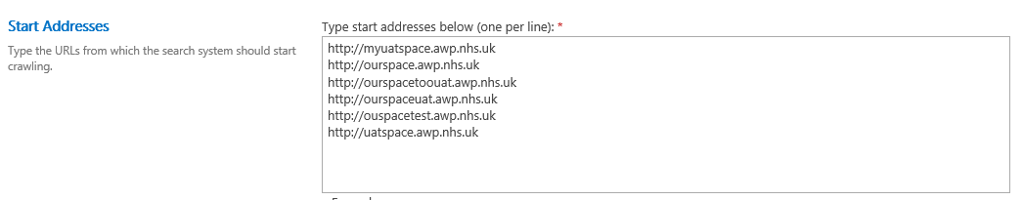

### UPS

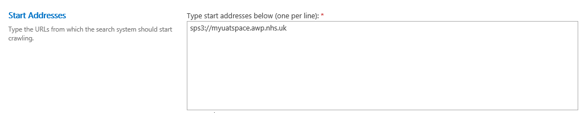

### Error Breakdown

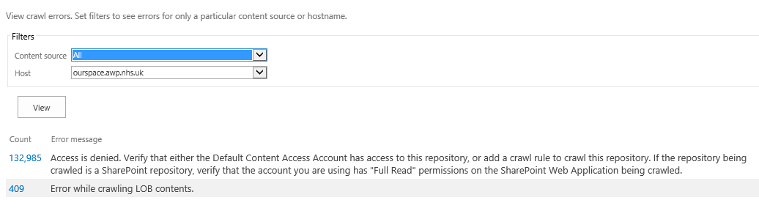

### Host Name

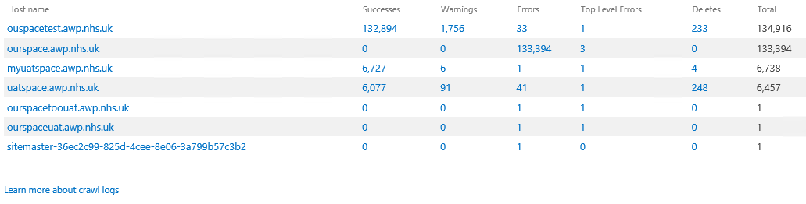

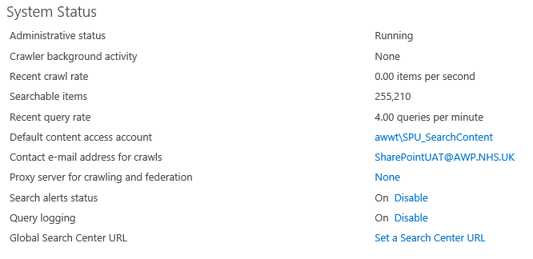

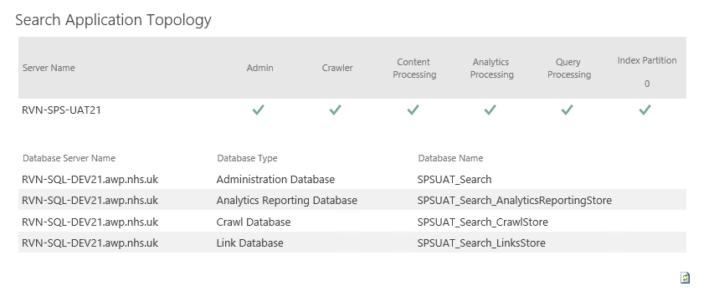

Crawl is stuck in the stopping state.

